UI Test Execution and Observation/Defect Evidence

Verify the Content, Label and Display 2
Verify the Content, Label and Display of Buy Energy "Home" page - FAIL 2
Observation 1: Back to Home page link is missing which allows user to go back to home page from sell some energy and About us page. 3
Verify the Content, Label and Display of "About" Page - FAIL 4
Observation 2- An extra period at the end of the text ‘Corp..’ is NOT required. 4
Verify the Content, Label and Display of "Contact" Page - FAIL 4
Observation 3 - Period at the end of the text ‘Contact’ is NOT required. 4
- Relevant contact information should be shown to the user. No error message should be displayed on page as it is currently displayed. 4
Verify Buy Energy screen with its content, division - FAIL 5
Observation 4: End period in first sentence is required i.e. after the sentence ending with ‘open’. 6
End period in 2nd sentence is required instead of comma i.e. after the sentence ending with ‘*for you to buy’ and only end period after ‘press that buy button’. 6
End period in 3rd sentence is required i.e. after the sentence ending with ‘*click the button below’. 6
Verify Detail showing in Tabular format with headers like Energy Type |Price|Quantity of Units Available|Number of Units Required" - FAIL 6
Observation 5: There is Spelling mistake in 3rd column header in the table. Quantity is mentioned as “Quanity” 6
Verify Price showing correct Unit based on its Energy Type - FAIL 6
Observation 6: Unit for Oil should be “per Litre” instead of “per Litres” 7
Verify Buy Energy screen to display Energy Types as Gas,Nuclear, Electricity, Oil"- PASS 7
Verify the availability of Buy and Reset button on the Buy Energy screen - PASS 8
Verify the alignment and information of the discount banner on the right side of the Buy Energy Table - FAIL 8
Observation 7: It should show the same discounted percentage in the SAVE label which is in Red. Currently discount is 30% but the Save is 20% which is quite confusing and wrong. Also the alignment is not appropriate. 8
Validate Buy Button Functionality using boundary value 10
Verify Buy button with valid available quantity - PASS 10
Verify Buy button by entering more than available quantity - FAIL 11
Observation 8: Quantity of units available header is capturing negative value 11
Verify Buy button by entering value other than numbers in Number of Units Required input box - FAIL 12
Observation 9: User is directed to Error log page when user enters any random value or character in number of units required input box. 12
Verify Buy button by entering negative numbers in Number of Units Required input box - FAIL 13
Observation 10: User is able to enter any negative value in Number of unit required input field and able to click on Buy button. 13
Verify Buy Button availability on screen when Quantity of Units Available is '0' - PASS 14
Verify Reset Button Functionality 14
Verify Reset button when there are few purchases already made - PASS 14
Verify Buy more link 16
Verify Buy more link navigation -PASS 16
Verify Back to Home page link 17
Verify Back to Home page link navigation - PASS 17
Verify launching this website in different browser 18
Verify launching in Chrome/IE/MS Edge and check the behaviour 18
Security Test 18
Reset - Without using Bearer Token 18
Verify the Bearer Token Expiry time; 18

Verify the Content, Label and Display

Verify the Content, Label and Display of Buy Energy "Home" page - FAIL

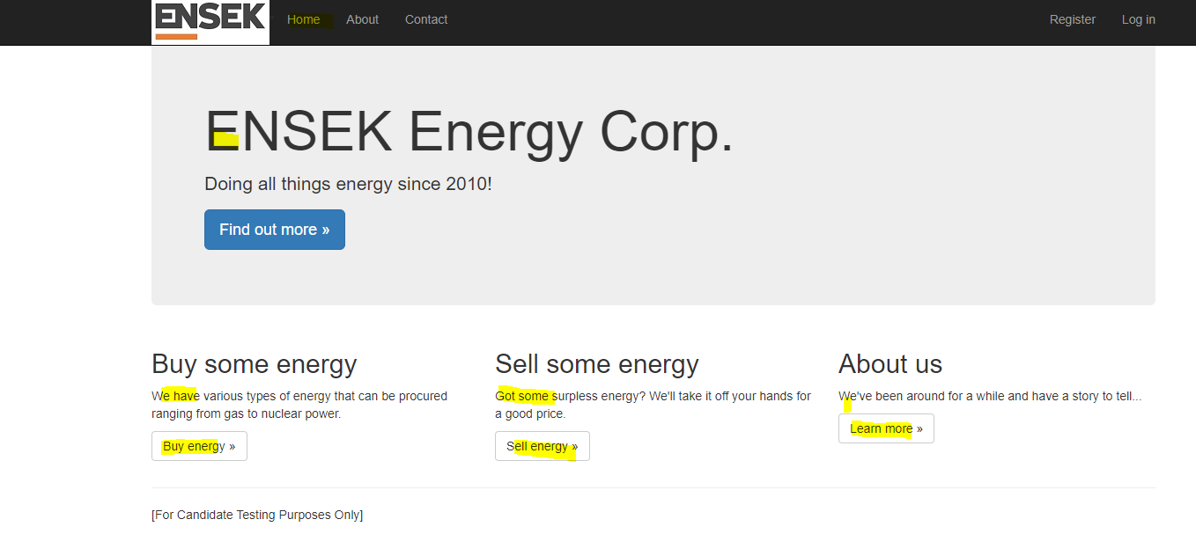
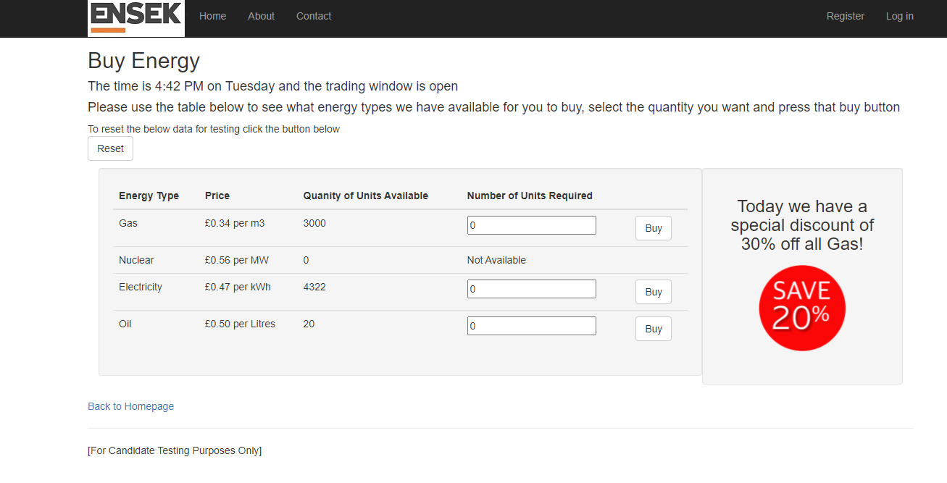

Observation 1: Back to Home page link is missing which allows user to go back to home page from sell some energy and About us page.
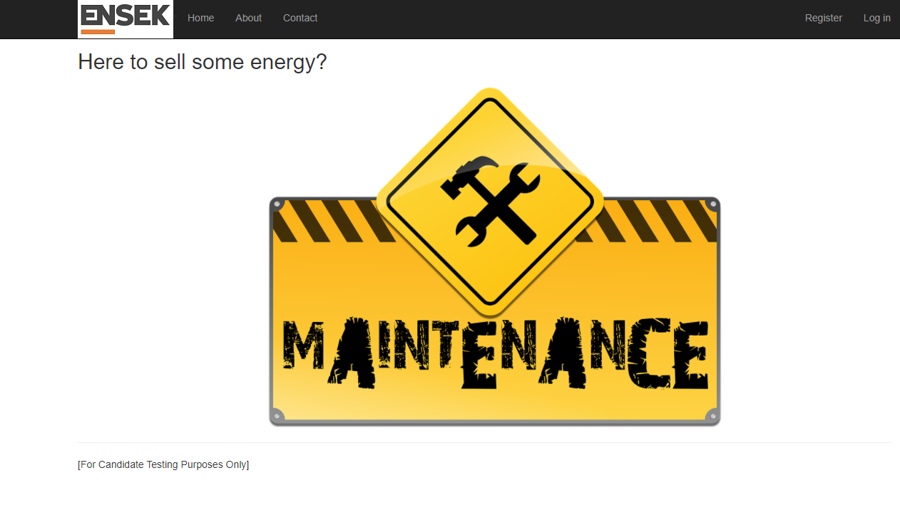
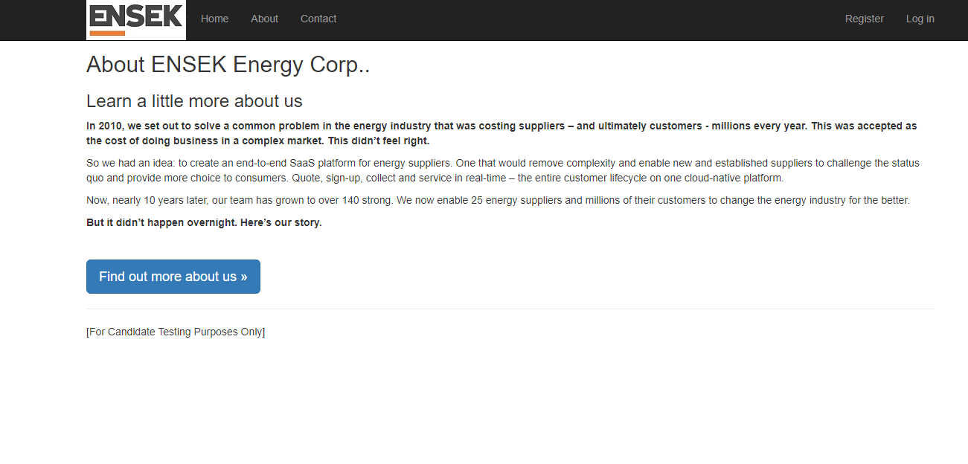

Verify the Content, Label and Display of "About" Page - FAIL

Observation 2- An extra period at the end of the text ‘Corp..’ is NOT required.

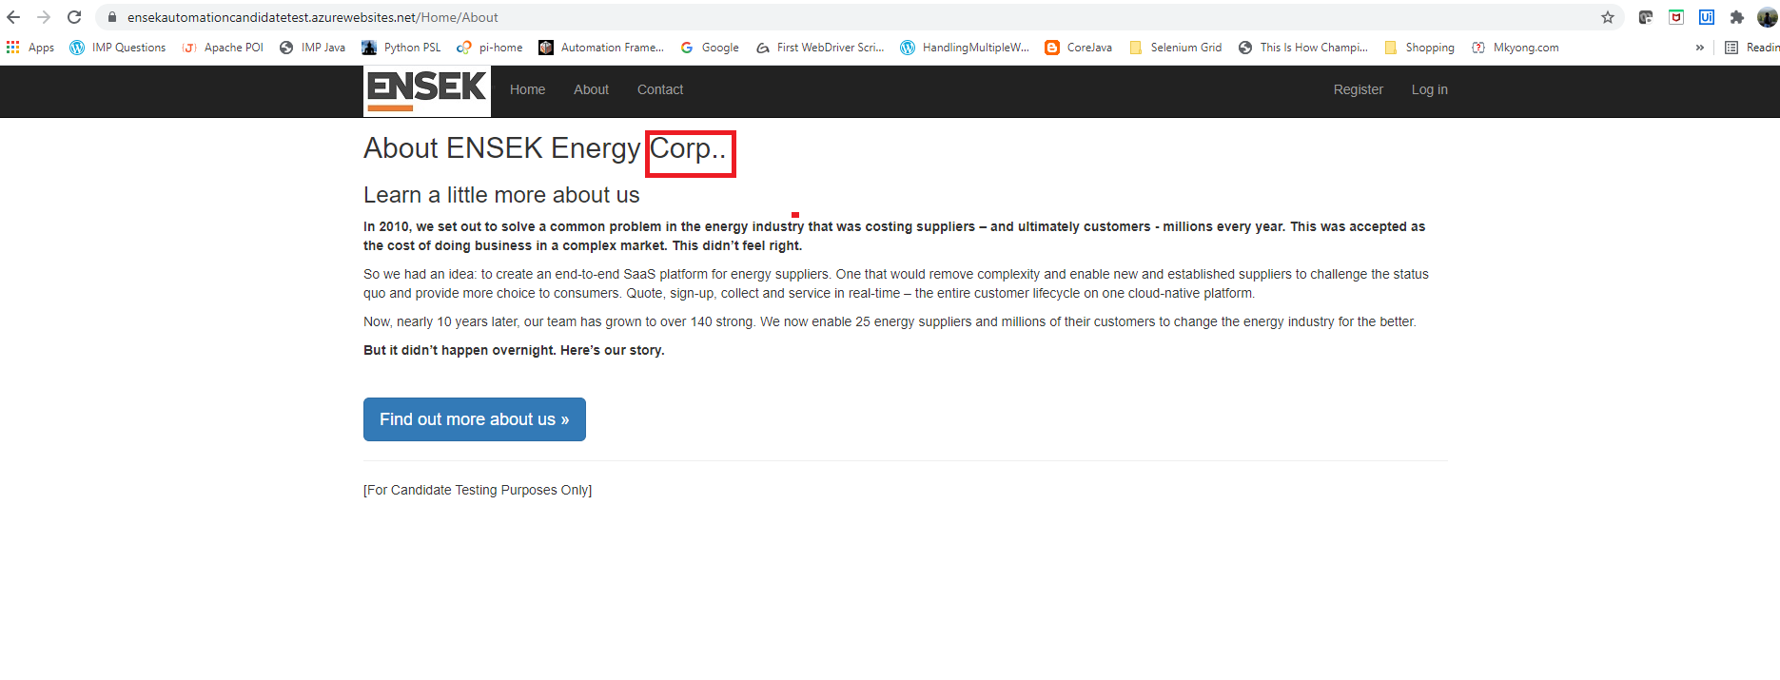

Verify the Content, Label and Display of "Contact" Page - FAIL

Observation 3 - Period at the end of the text ‘Contact’ is NOT required.
- Relevant contact information should be shown to the user. No error message should be displayed on page as it is currently displayed.
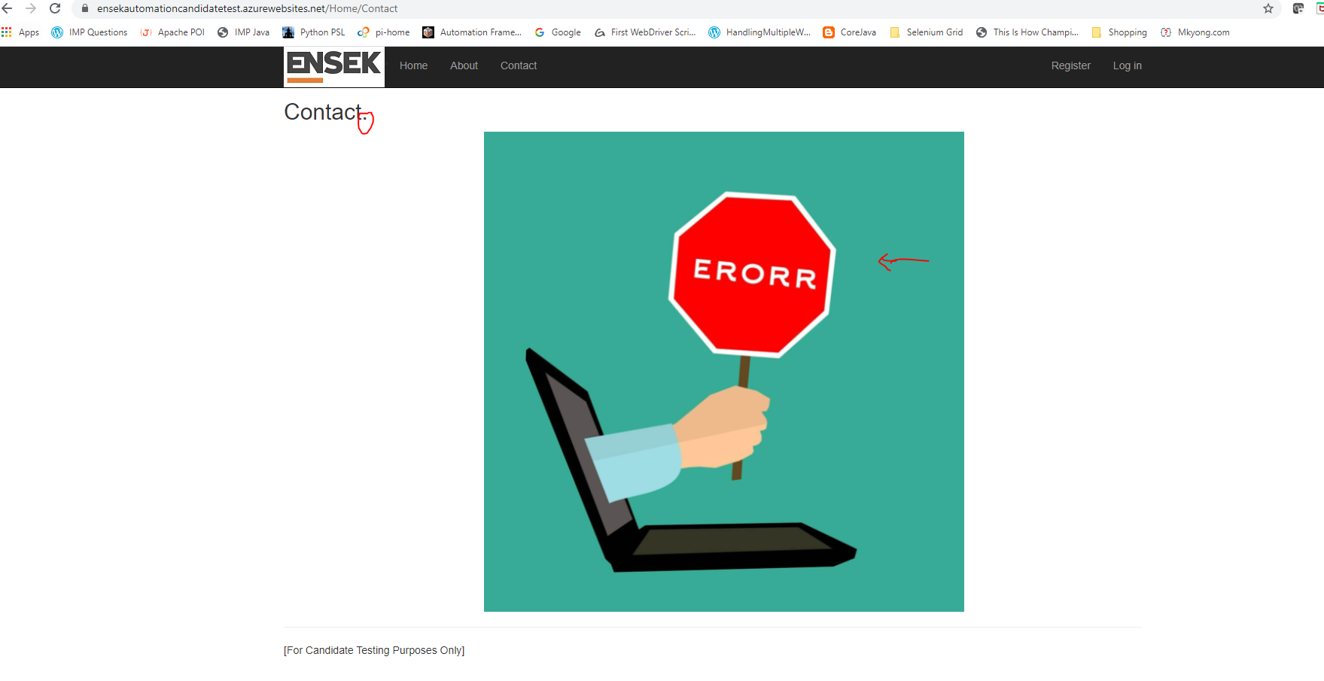

Verify Buy Energy screen with its content, division - FAIL

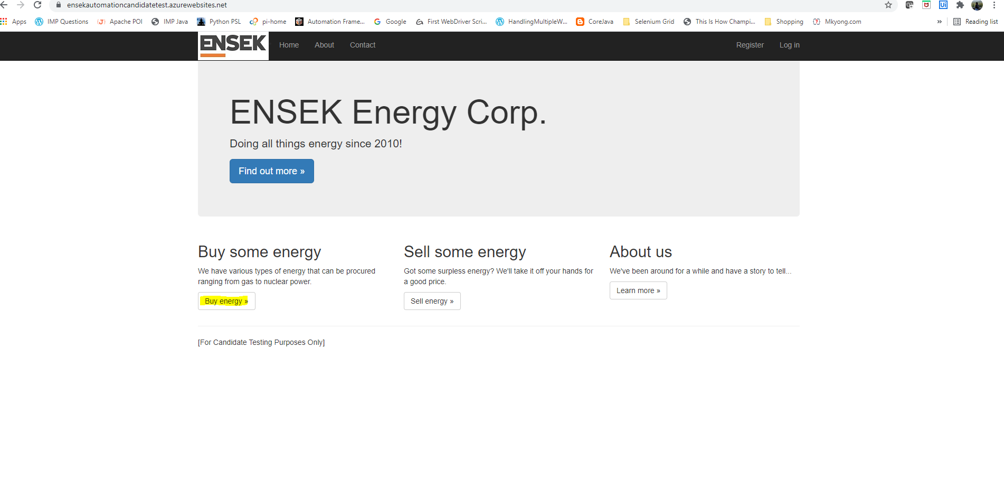
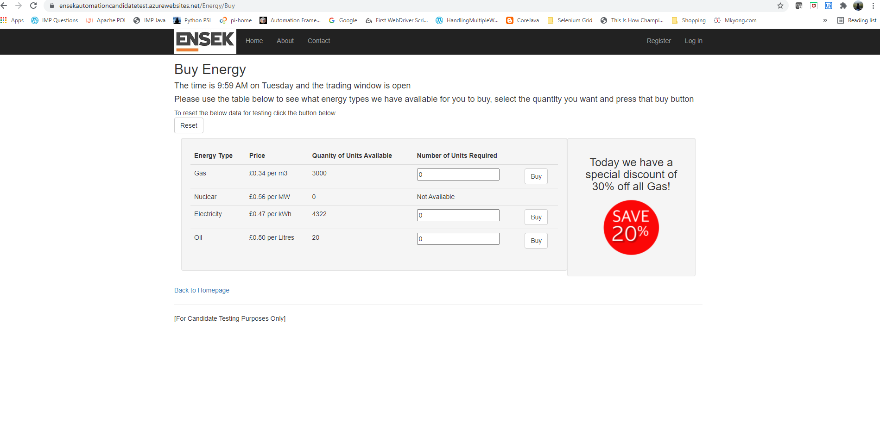

Observation 4: End period in first sentence is required i.e. after the sentence ending with ‘open’.

End period in 2nd sentence is required instead of comma i.e. after the sentence ending with ‘*for you to buy’ and only end period after ‘press that buy button’.

End period in 3rd sentence is required i.e. after the sentence ending with ‘*click the button below’.

Verify Detail showing in Tabular format with headers like Energy Type |Price|Quantity of Units Available|Number of Units Required" - FAIL

Observation 5: There is Spelling mistake in 3rd column header in the table. Quantity is mentioned as “Quanity”
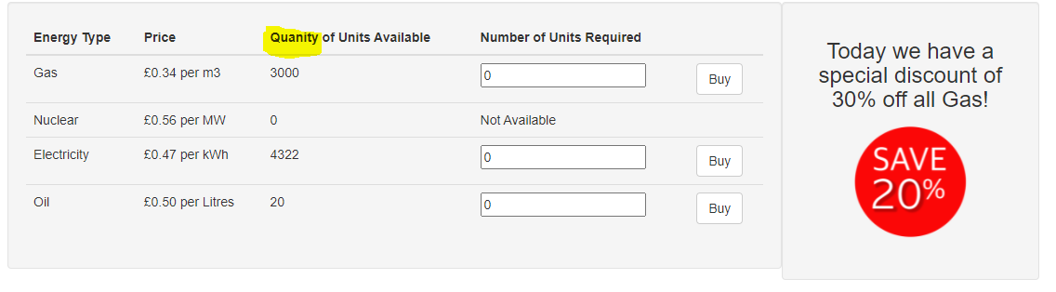

Verify Price showing correct Unit based on its Energy Type - FAIL

Observation 6: Unit for Oil should be “per Litre” instead of “per Litres”
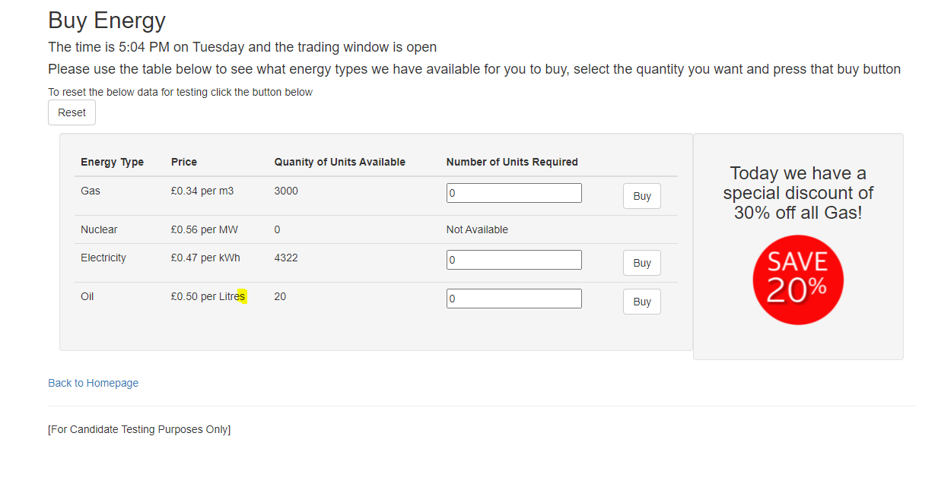

Verify Buy Energy screen to display Energy Types as Gas,Nuclear, Electricity, Oil"- PASS
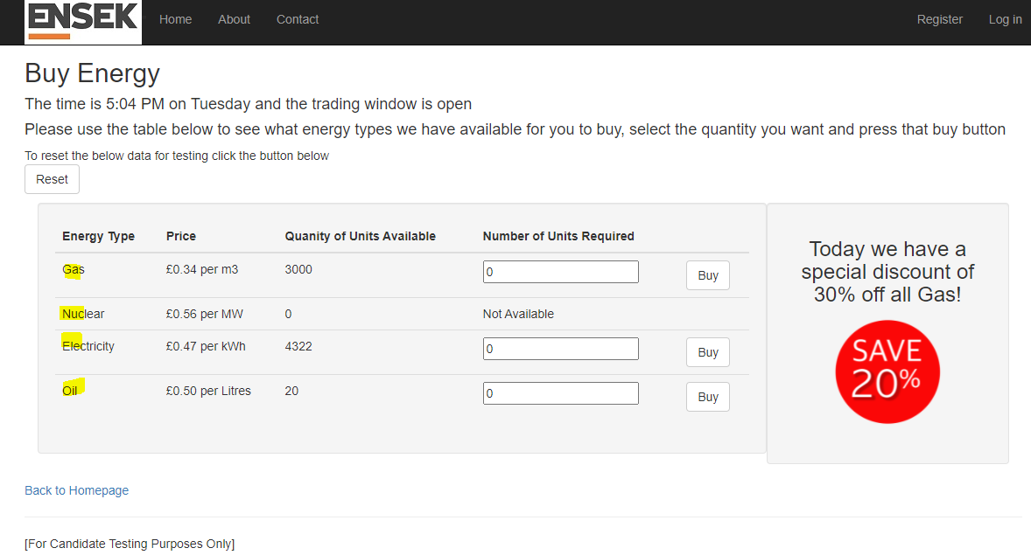

Verify the availability of Buy and Reset button on the Buy Energy screen - PASS
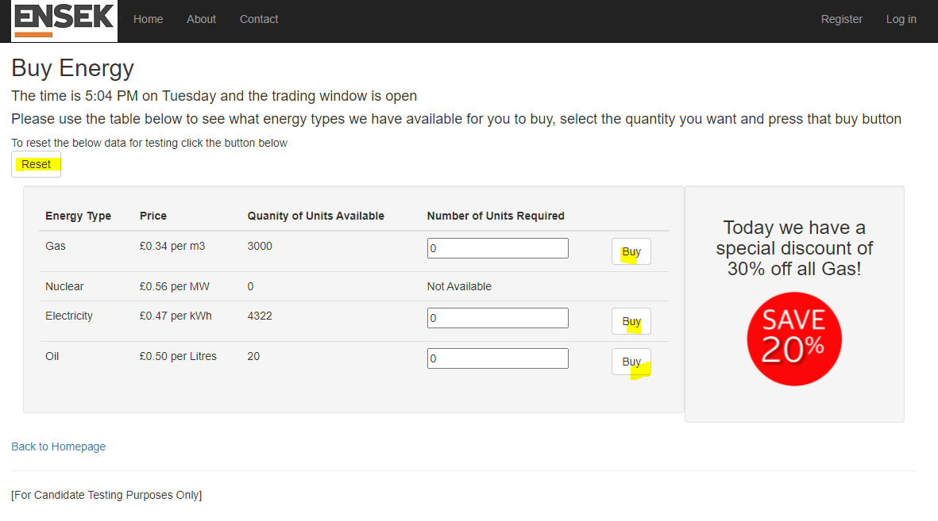

Verify the alignment and information of the discount banner on the right side of the Buy Energy Table - FAIL

Observation 7: It should show the same discounted percentage in the SAVE label which is in Red. Currently discount is 30% but the Save is 20% which is quite confusing and wrong. Also the alignment is not appropriate.

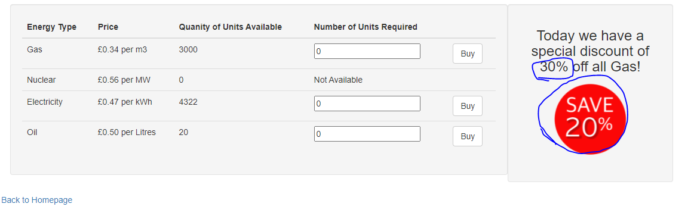
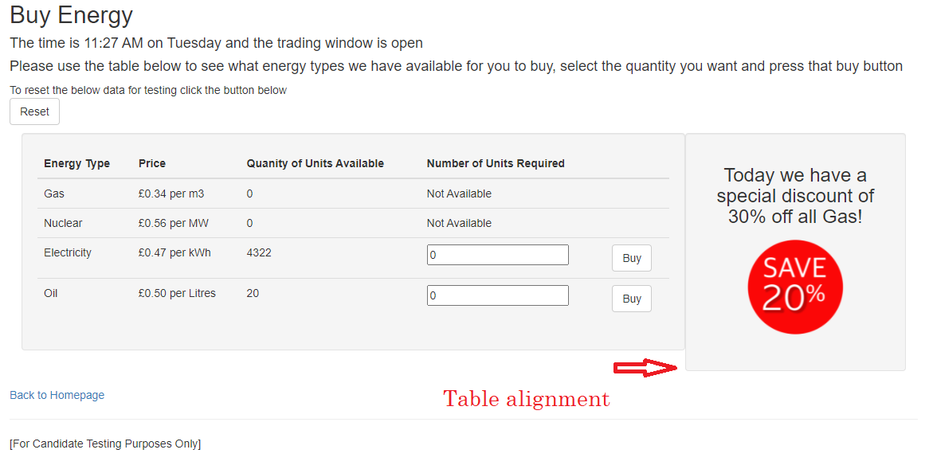

Validate Buy Button Functionality using boundary value

Verify Buy button with valid available quantity - PASS
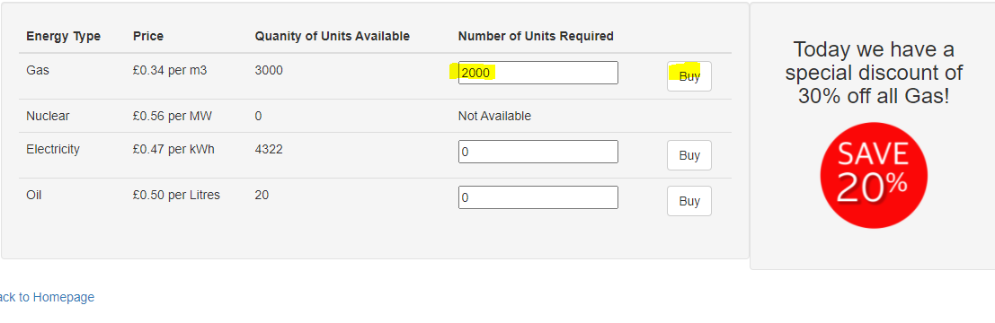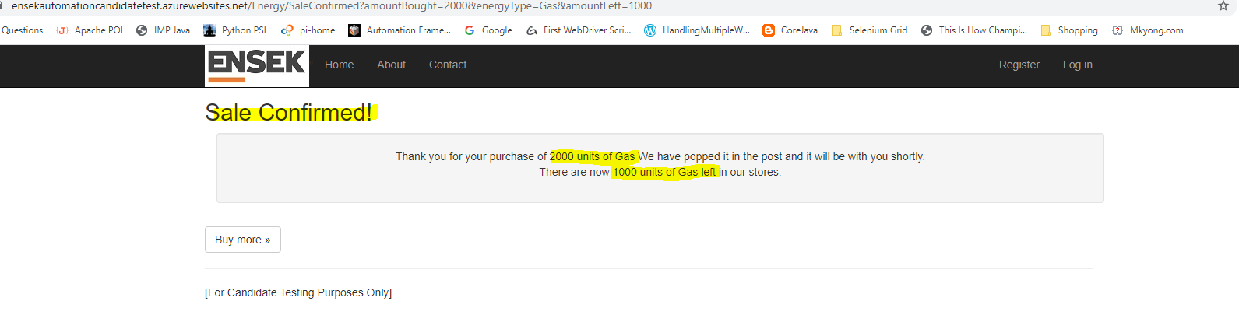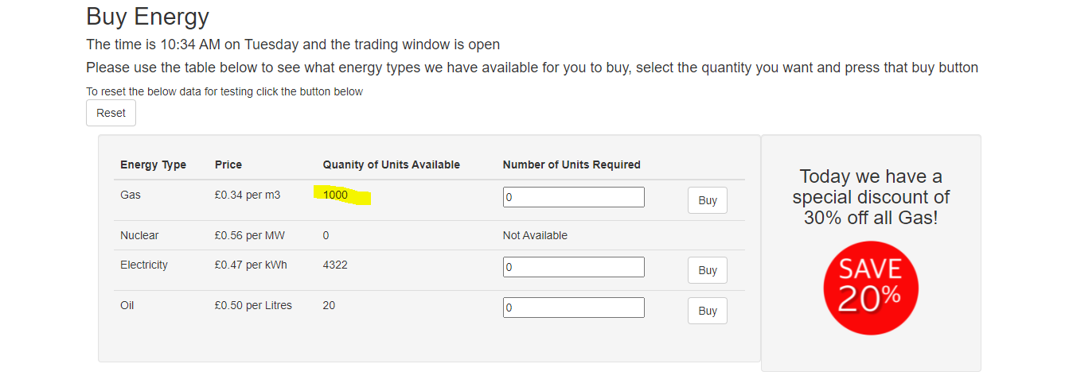

Verify Buy button by entering more than available quantity - FAIL

Observation 8: Quantity of units available header is capturing negative value
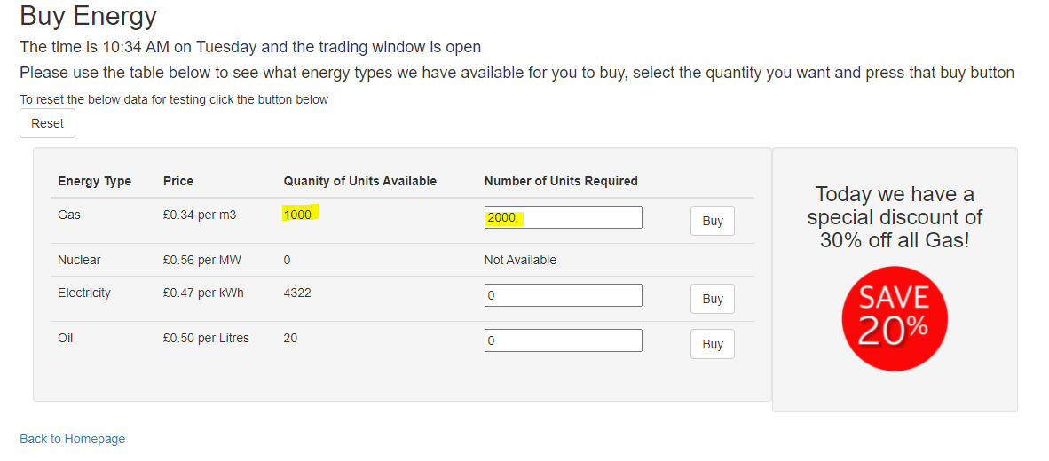

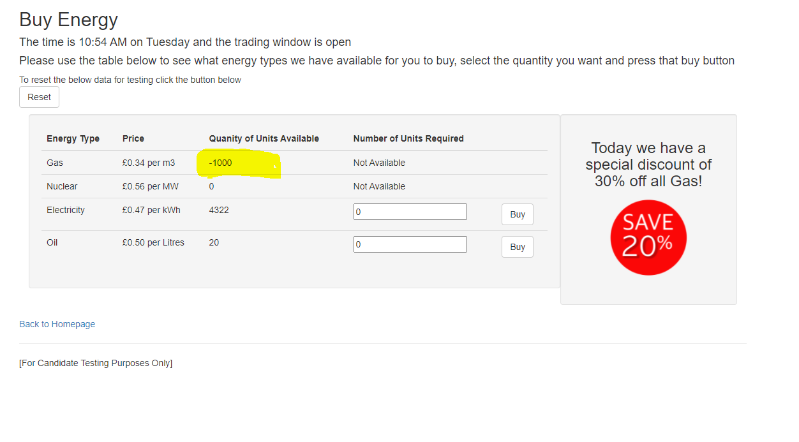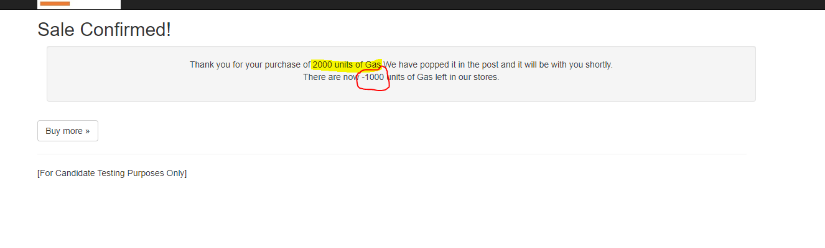

Verify Buy button by entering value other than numbers in Number of Units Required input box - FAIL

Observation 9: User is directed to Error log page when user enters any random value or character in number of units required input box.
Ideally it should not show any exception error log on page even if the input string is not appropriate rather should show informative simple text message. Additionally, there should be appropriate input field validation.
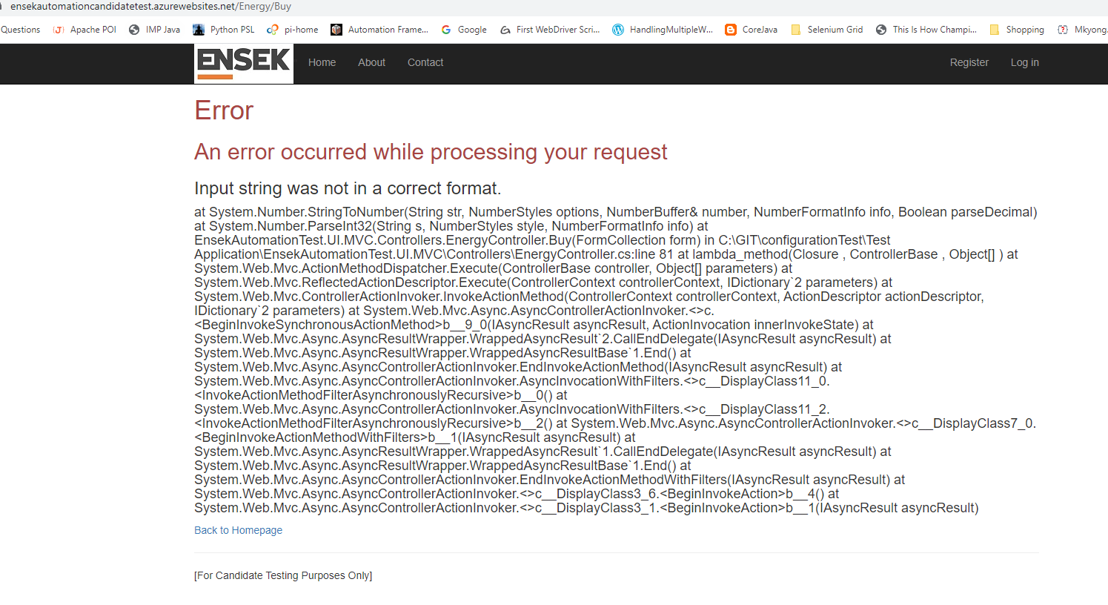

Verify Buy button by entering negative numbers in Number of Units Required input box - FAIL

Observation 10: User is able to enter any negative value in Number of unit required input field and able to click on Buy button.

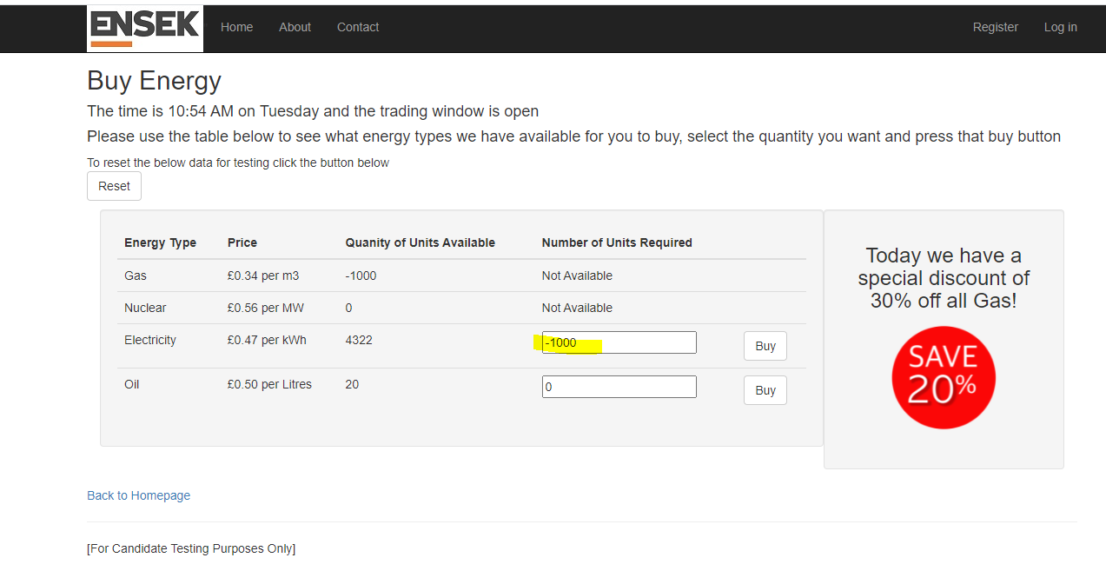
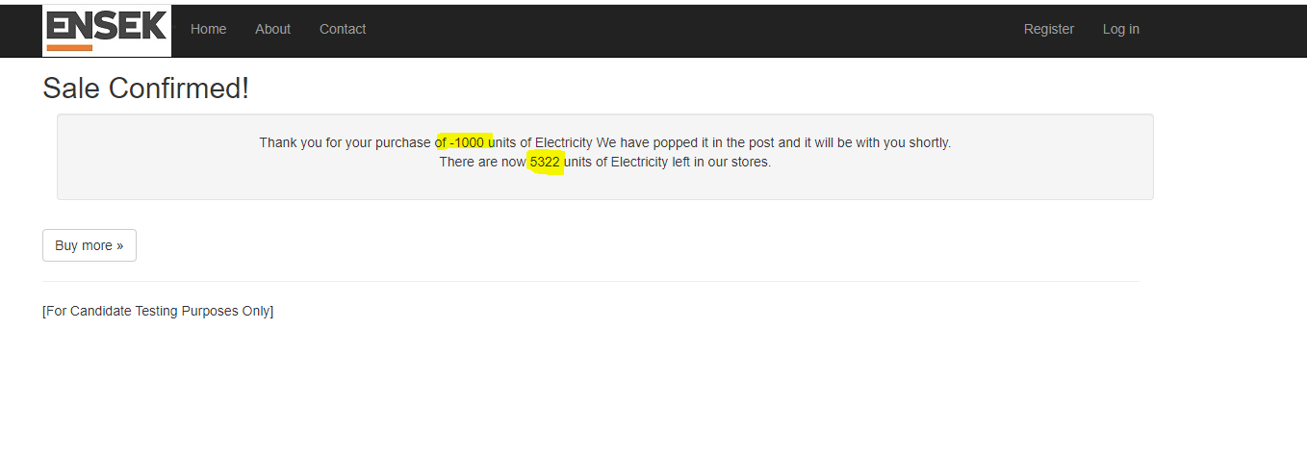

Verify Buy Button availability on screen when Quantity of Units Available is '0' - PASS
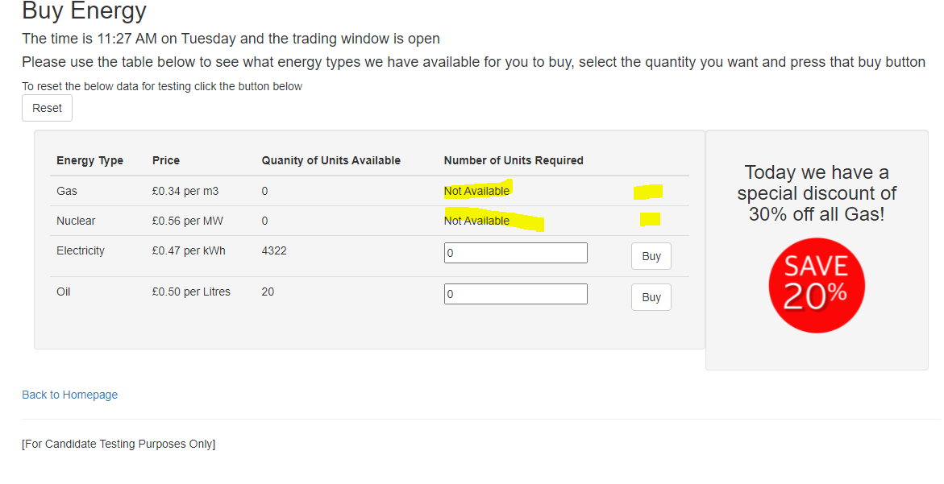

Verify Reset Button Functionality

Verify Reset button when there are few purchases already made - PASS
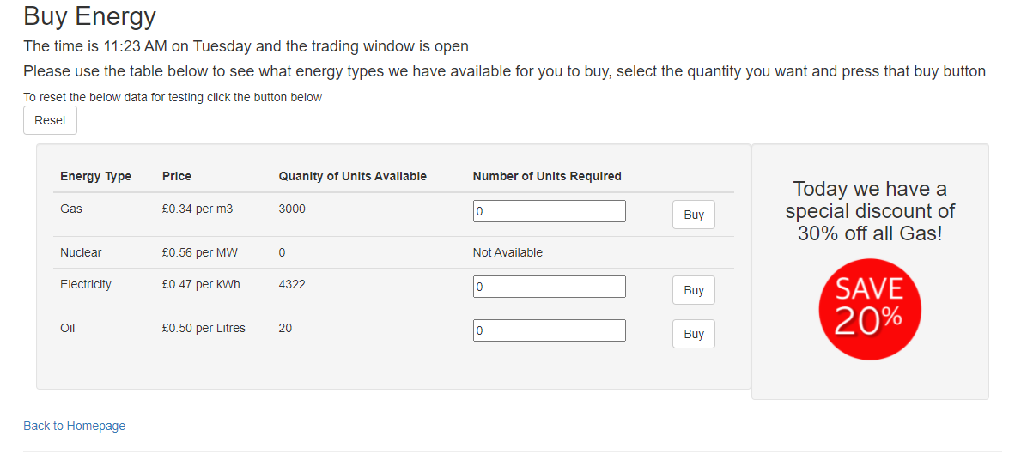
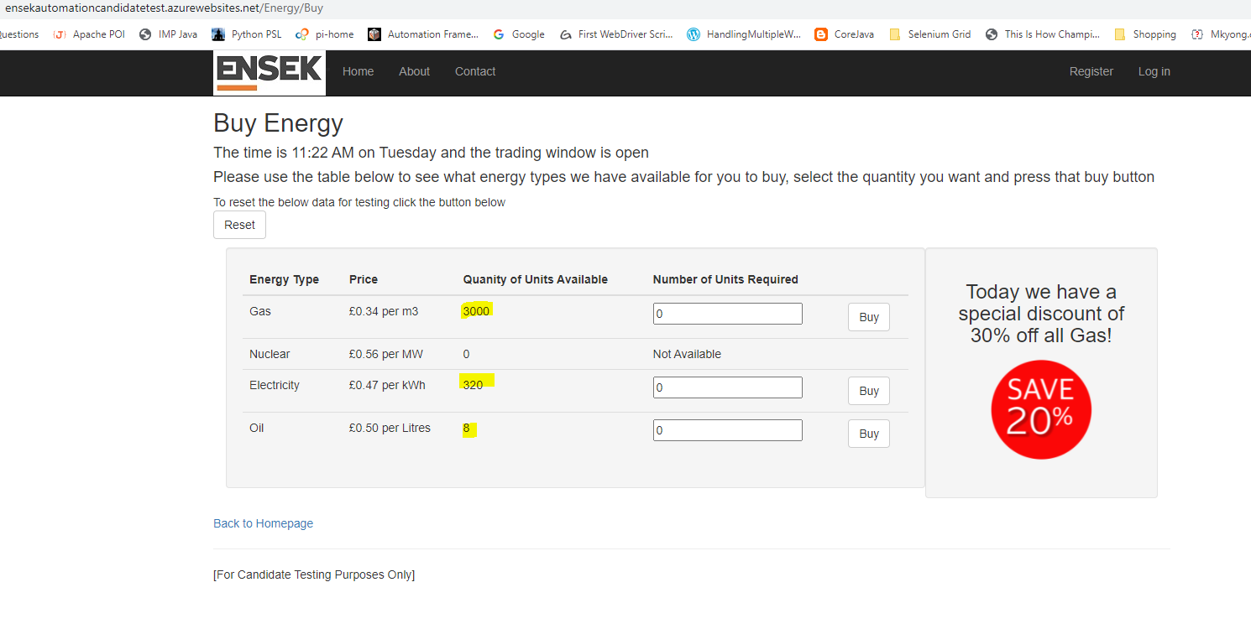
Click on reset button
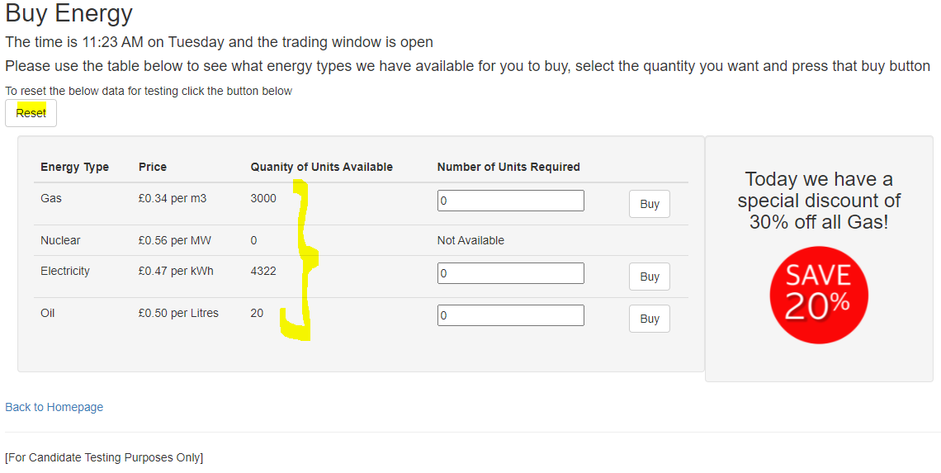

Verify Buy more link

Verify Buy more link navigation -PASS

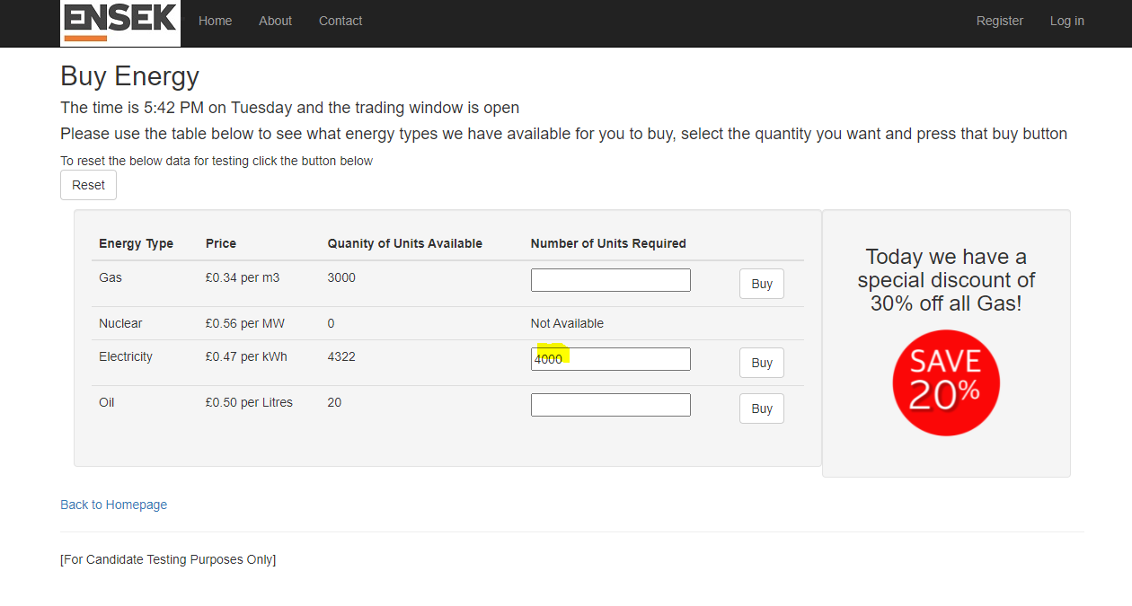

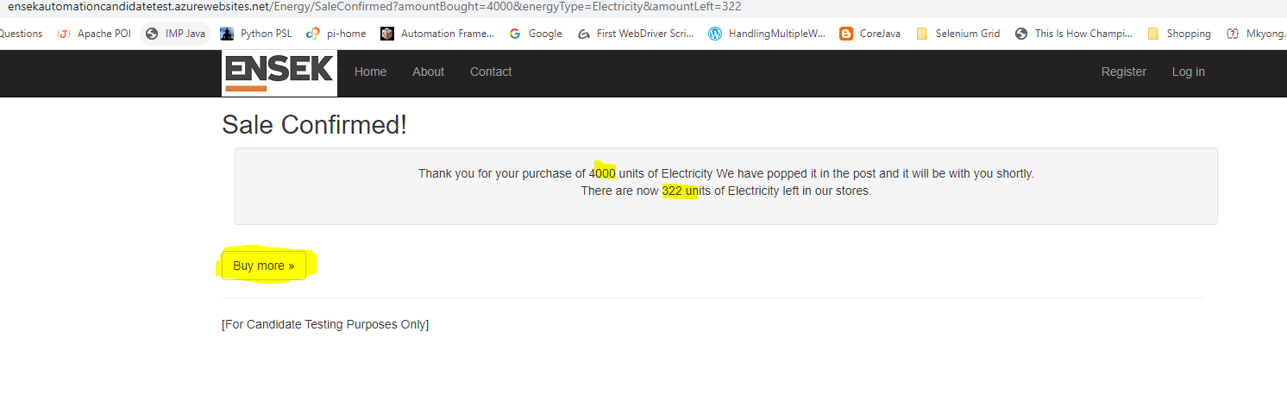
Click on Buy more link. It should direct back user to Buy energy updated table.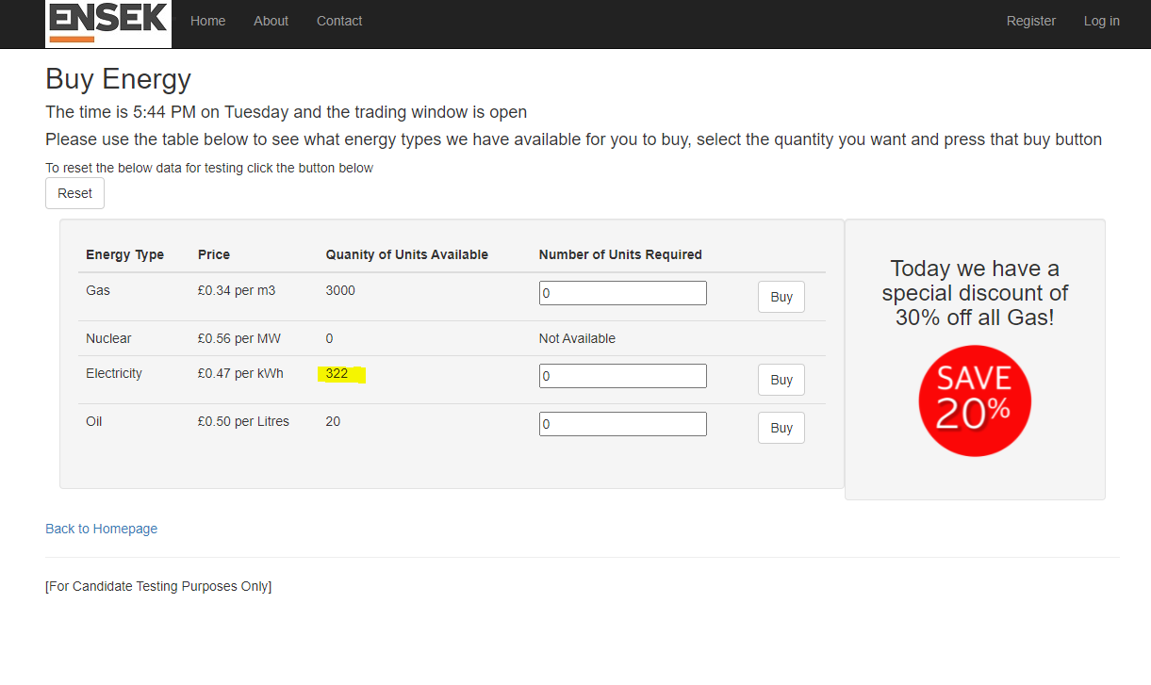

Verify Back to Home page link

Verify Back to Home page link navigation - PASS

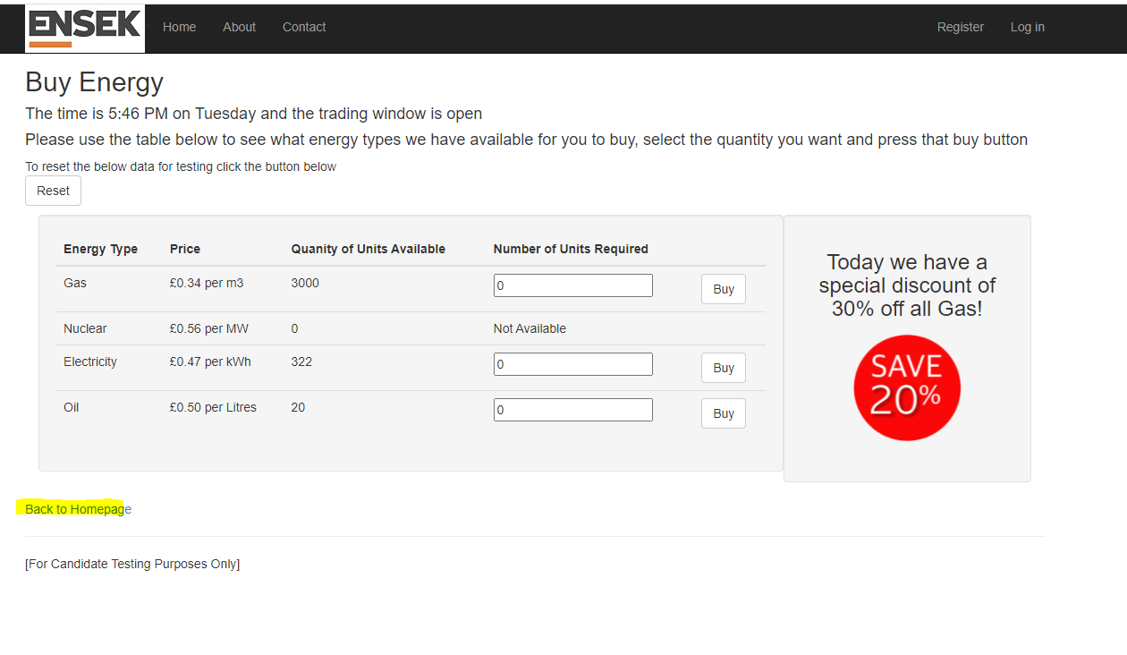
Clicking will direct the user to home page
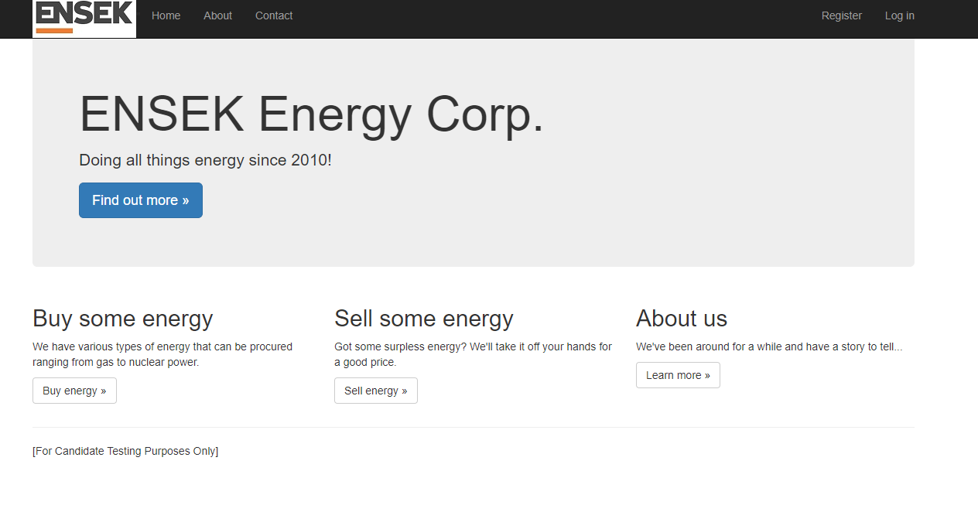

Verify launching this website in different browser

Verify launching in Chrome/IE/MS Edge and check the behaviour

Security Test

Reset - Without using Bearer Token

Verify the Bearer Token Expiry time;

